Community Assessment Report
Karns City Communities That Care

- Bi-Annual Assessment Report
- Prepared by KC CTC Data Committee
- 9/14/2022
- Butler County Human Services

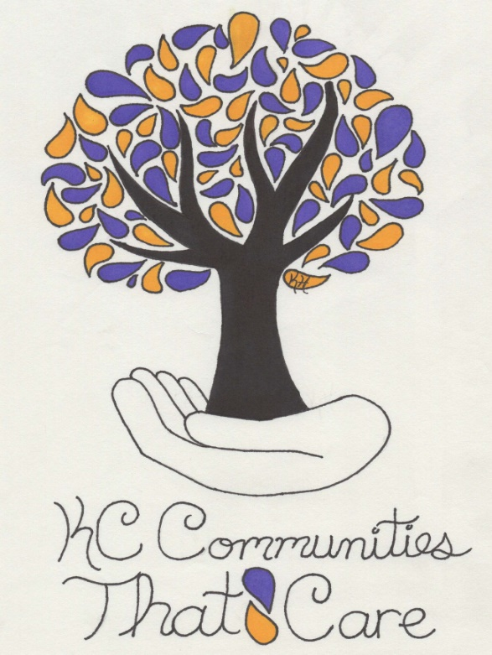

Community Assessment Report Outline

I. Executive Summary

II. Introduction
A. The Karns City Communities That Care effort
- About the Communities That Care system
- Key accomplishments in Karns City Communities That Care
B. The risk- and protective-factor assessment
- Goals
- How the assessment will be used
- Data collection methods
- Prioritization methods

III. The Community Assessment Data
- Risk factors
- Community Domain
- Family Domain
- School Domain
4. Peer and Individual Domain
B. Protective factors
- Community Domain
- Family Domain
- School Domain
- Peer and Individual Domain
C. Problem behaviors

IV. Conclusion
- Community strengths
- Community priorities
- Next steps

V. Appendices
- References
- Acknowledgments

Executive Summary

This report describes the results of the risk- and protective-factor assessment completed as part of Karns City’s Communities That Care effort. The Communities That Care system is a way for members of a community to work together to prevent youth problem behaviors, including substance use, delinquency, teen pregnancy, dropping out of school and violence. This system was developed by Dr. David Hawkins and Dr. Richard Catalano. It is based on their research, which has identified risk factors that predict youth problem behaviors and protective factors that buffer children from risk and help them succeed in life.

A key goal of the Communities That Care effort is to identify which risk factors, protective factors and problem behaviors are prevalent in our community, and implement evidence-based programs that address our community’s unique profile. To that end, the Data Assessment work group collected and analyzed data on the Karns City area. Then, with input from the community, they identified priority risk factors to address, as well as community strengths to build on.

The assessment was completed using the PAYS and publically available data. The PAYS was administered to students in grades 6-12 in all schools in Karns City in the fall of 2021. To get the most complete picture of our community, the Risk and Protective-Factor Assessment work group also collected data from public records to measure risk factors and problem behaviors not covered by the survey.

Based on the analysis of the data and input from the community, the following risk factors were identified as priorities for community attention:

- Attitudes Favorable Toward Drug Use (Peer and Individual Domain)
- Low Commitment to School (School Domain)

These risk factors were selected as priorities for prevention action primarily because data indicated that they are significantly elevated throughout Karns City. The data also revealed strengths in the Karns City area. For example, the PAYS revealed that students are motivated to follow society’s expectations and standards. They reported high levels of the protective factor “Belief in the Moral Order” and low levels of the risk factor “Rebelliousness.” This is an important area of strength on which to build to help promote well-being and protect our youth from the risk of health and behavior problems. Youth in the Karns City area also showed high levels of Family Attachment and expressed a high level of protection through Opportunities for Pro-Social Involvement in the family domain.

This report recommends that the community give particular attention to the risk factors noted above when developing the community’s action plan to prevent youth health & behavior problems and promote child and youth well-being.

Introduction

The Karns City Communities That Care
In the fall of 2015, Karns City began implementing the Communities That Care prevention planning system. Developed by Dr. David Hawkins and Dr. Richard Catalano of the Social Development Research Group in Seattle, Washington, the Communities That Care system is a way for members of a community to work together to promote positive youth development and prevent youth problem behaviors such as substance use, delinquency, teen pregnancy, dropping out of school and violence efficiently and effectively.

Karns City implemented the Communities That Care process to achieve the community’s vision that all young people in the Karns City area grow up supported and nurtured by their families, schools and community, and become healthy adults who contribute positively to society.

Key accomplishments to date:
- The PAYS has been administered to 6-12th graders in Karns City schools on a biyearly basis since 2015, most recently in 2021.
- In January 2016 a Community Board was formed. Members attended the Community Board Orientation and established a structure for the Karns City Communities That Care effort. This included forming work groups to achieve the various steps in implementing the Communities That Care system. Since then, we have established 12 board members from various sectors.
- We have held several community events to provide information and to increase awareness of the Communities that Care efforts in our area.
- We have established five working groups which include, Data, Resource Assessment, Youth, PR/Board Maintenance, and Funding.
- We have successfully started and maintained three evidence based program, which targets both youth (K-12) and parents.
- In late July early August, the Data Assessment work group attended the Community Assessment Workshop and developed a plan for completing the community risk- and protective factor assessment. This report is the result of that assessment.

The Community Assessment
Dr. Hawkins and Dr. Catalano have identified risk factors that predict problem behaviors in youth, and protective factors that help protect young people from those risks. By addressing risk and protective factors, communities can help prevent adolescent problem behaviors and promote positive youth development. A key goal of the Communities That Care system is for communities to develop a profile of the risk factors, protective factors and problem behaviors in their community, and to develop a plan for addressing the risk factors that are most elevated while enhancing protective factors.

This report represents the first step in that process. The Risk- and Protective-Factor Assessment work group has collected data on risk factors, protective factors and problem behaviors in Karns City. With input from the community, the work group has identified our community’s strengths and the priority risk factors to address in the prevention plan.

Data collection methods
As noted above, the PAYS had been most recently administered in 2021. All students in grades 6, 8, 10, & 12 were asked to participate. The complete results are provided in the Karns City PAYS report. In addition, Dr. Hawkins and Dr. Catalano have identified public data indicators that have been shown to be valid and reliable measures of certain risk factors and problem behaviors that are not measured by the survey, namely Extreme Economic Deprivation, Availability of Drugs and Alcohol, Teen Pregnancy and School Drop-Out. The Data Assessment work group collected data from local and state agencies to supplement the youth survey.

How the priorities were identified
The Risk- and Protective-Factor Assessment (data) work group analyzed the data to identify which risk factors are most elevated in Karns City. This committee met throughout the summer to look at the PAYS data including where each category of Karns City’s information fell in comparison with state and national averages, movement up or down in scores from the 2019 PAYS scores in Karns City, publicly available data, and the community’s own knowledge of the Karns City area communities.

Report Overview
The next sections of the report provide detailed information and analysis of the risk factors, protective factors and problem behaviors in Karns City. The conclusion presents the final list of priorities and recommendations for future action.

Risk Factor: Attitudes Favorable towards Drug Use

During the elementary school years, most children express anti-drug, anti-crime, and pro-social attitudes and have difficulty imagining why people use drugs or engage in antisocial behaviors. However, in middle school, as more youth are exposed to others who use drugs and engage in antisocial behavior, their attitudes often shift toward greater acceptance of these behaviors. Youth who express positive attitudes toward drug use and antisocial behavior are more likely to engage in a variety of problem behaviors, including drug use.

16.2% of students in this district stated their parents felt it “a little bit wrong” or “not at all wrong” to drink alcohol (state rate: 10.2%) and 10.8% stated that their parents felt it was “a little bit wrong” or “not at all wrong” to use marijuana (state rate: 10.8%). 27.1% of the students thought it was “a little bit wrong” or “not at all wrong” for someone their age to use alcohol (state rate: 15.6%) and 27.5% thought it was “a little bit wrong” or “not at all wrong” for someone their age to use marijuana (state rate: 25.6%).

This risk factor has been shown to cause an increased chance for the following problem behaviors to occur:
- Substance Abuse
- Delinquency
- Teen Pregnancy
- School Drop-Out
- Violence

For these reasons, this risk factor has been identified as a priority for Karns City.

These values are based on percentages of students per grade level.
Risk Factor: Low Commitment to School

Lack of commitment to school means the child no longer sees the role of student as meaningful and rewarding. Young people who have lost this commitment to school are at higher risk for five of the six health & behavior problems.

For the risk factor, Lack of Commitment to School, we have seen an improvement in Karns City area youth in 6th and 10th grade. However, 8th and 12th grade show levels of risk exceeding State average levels.

Protective Factor: Rewards for Pro-Social Involvement (Community Domain)

Rewards for positive participation in activities helps youth bond to the community, thus lowering their risk for substance use.

This protective factor was not the lowest protective factor recorded for students in the Karns City area, however, the data committee was encouraged by some of the areas of responses in the “Rewards for Pro-Social Involvement” protective factor provided in the PAYS report. The committee feels that this is an area where our community can get behind and support. This is a protective factor that will help to raise overall protection in our area and gives us the greatest chance to positively impact change for youth.
Conclusion and Recommendations

Karns City Area’s Strengths
The data revealed that young people in Karns City are motivated to follow society’s expectations and standards. In particular, protective factors grouped in the “family” domain” are particularly strong. Young people also reported high levels of the protective factor “Belief in Moral Order” and low levels of the risk factor “Rebelliousness.” Karns City Communities That Care should work to build on this strength while enhancing other protective factors in its prevention efforts.

Many risk factors in the Karns City area became greater risks in 2021 compared with 2019. Some examples of areas where this community still exhibits low levels of risk are in “Gang Involvement”, “Interaction with anti-social peers”, and “Rewards for anti-social behavior”.

Community Priorities
Based on the analysis of the data and input from the community, the following priority risk and protective factors were identified for the community to focus on over the next several years:

- Attitudes Favorable Towards Drug Use (Peer and Individual Domain)
- Lack of Commitment to School (School Domain)
- Rewards for Pro-Social Involvement (Community Domain)

These risk factors were selected as priorities because the data indicated that they are among the most elevated throughout the Karns City area. We recommend that Karns City Communities That Care gives particular attention to implementing strategies or programs to address these two risk factors and one protective factor when developing a prevention plan.

Next Steps
The next step in the Communities That Care process is to find out what resources are already in place in Karns City that address the priorities outlined above. The Resources Assessment and Evaluation work group will attend the Assessing Community Resources Workshop in October. Their assessment combined with this report, will make up the profile of Karns City that will be used to identify programs and strategies to promote child and youth well-being and prevent health & behavior problems in the Karns City Area.

Boers, Reinecke, Seddig, & Mariotti, 2010; Catalano et al., 2011; Gottfredson, 2001; Guo, Hawkins, Hill, & Abbott, 2001; Jessor & Jessor, 1977; Kosterman et al., 2000; Najaka et al., 2001

